Xclusive Services Self Service Payroll Check Portal
(For Internal Employees Only)

Last Updated 01/26/2022

To access the Xclusive Service Check Portal click on the following link: Xclusive Payroll Portal

You will be asked to enter in your Login and Password
Your Login is the first part of your email address
Your Password is your Social Security Number
The very first time you log in you will be asked to select a new password.

If you forgot your password you can simply click the forgot your password and it will be emailed to you. Please make sure that you do not share your email password with anyone else or they could have access to your payroll information.

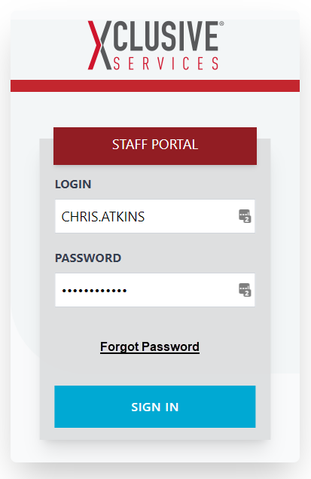

Once you log in you will be on the Home Screen. This screen displays your name and address. You also have the ability to do the following:
- Home: This is the screen below.
- Payroll: Get access to pdf copies of your payroll stubs.
- Time: Allows hourly employees to view their time that was entered from clock punches. (Note this feature is not live yet).
- Change your password.
- Logout.

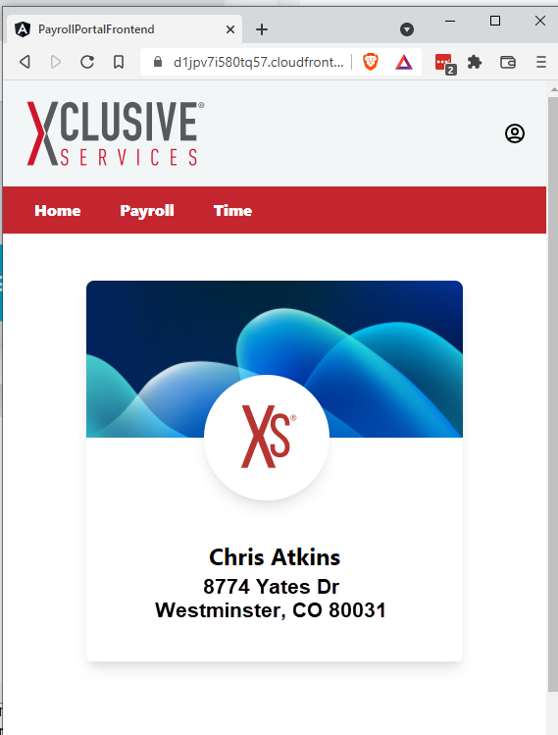

To change your password click on the 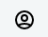 icon, and select “Change Password”.

To Logout click on the icon and select “Logout”, or close the browser window

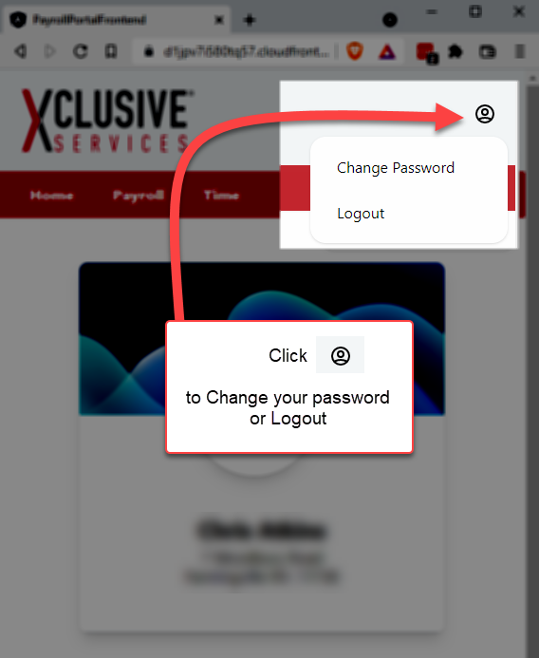

By clicking on the “Payroll” tab you will bring up a list of your last 10 checks

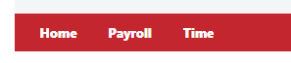

If you need to see a check further back in time, you can click the “SHOW MORE” button which will show all your checks.

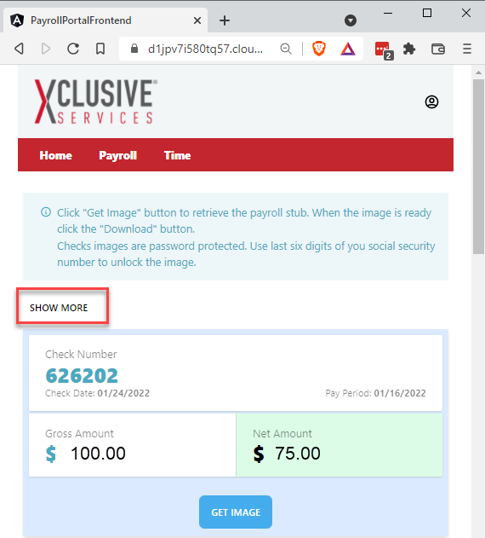

To view your check stub, you can click on the “Get Image” button. If the check is available, you will see the message “Download Check”. If it is not available, you will see the message “Check has been Archived”. Images of checks are only available from 01/01/2022 and forward.

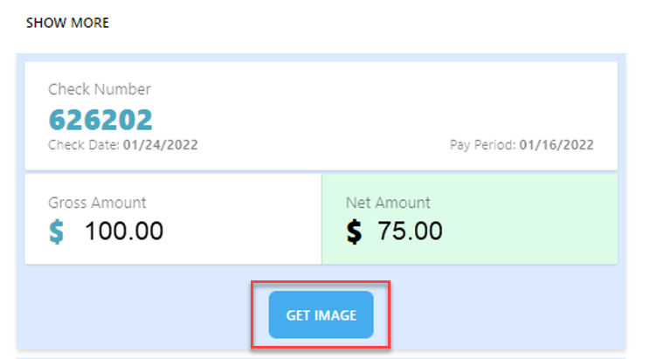

When you click on the download button a PDF copy of the check will be downloaded to your PC or phone. From there you can use your favorite PDF viewer to open the image.
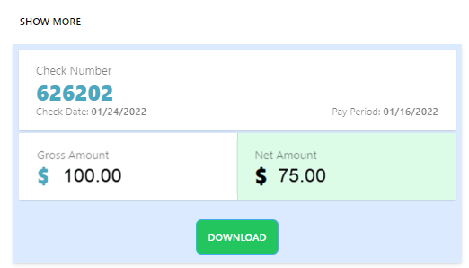

Please note that all checks have been password protected with the last 6 digits of your Social Security Number.

